LEXINGTON Engagement of Table and Sofa

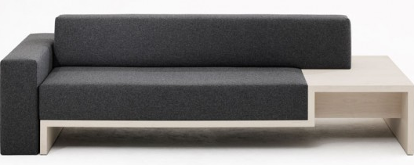

|  |
| --- |
| **DESCRIPTION** |
| Engaged Sofa produced by LEXINGTON Sofa, presents a sleek, and stylish which will add mass affection in homes and TV lounge perfect for a silent rest. The extra length of this sofa enables your body to adjust easily at will. The table attached in sofa makes it easy for user to increase size of the sofa and relax and eat at one place the long legs help to clean under the sofa. |

|  |  |  |
| --- | --- | --- |
| **Price** | **3555$** | |
| **Dimensions** | **H** x **W** x **L** | **34in x 33in x 67in** |
| **Features** | **Three users can sit at once on this sofa and Grey contains feature and color of both white and black which means it will adjust to the temperature of both summer and winter.** | |
| **Finished** | **Net cloth Finished** | |
| **Available in** | **Grey and dark Brown** | |